Lab_Day-23 (Matplotlib Bar plot and Histogram)

1: Visualize the daily temperature changes over time in a city and give your conclusion

Input: days = list(range(1, 32)) # Daily temperature data (replace with your own data)

temperature = [65, 68, 70, 72, 75, 76, 78, 80, 81, 79, 75, 72, 70, 68, 67, 69, 70, 73, 75, 76, 78, 80, 81, 82, 83, 82, 80, 78, 76, 74, 71]

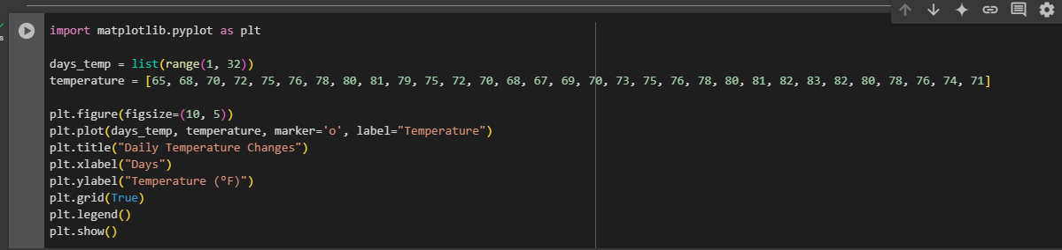

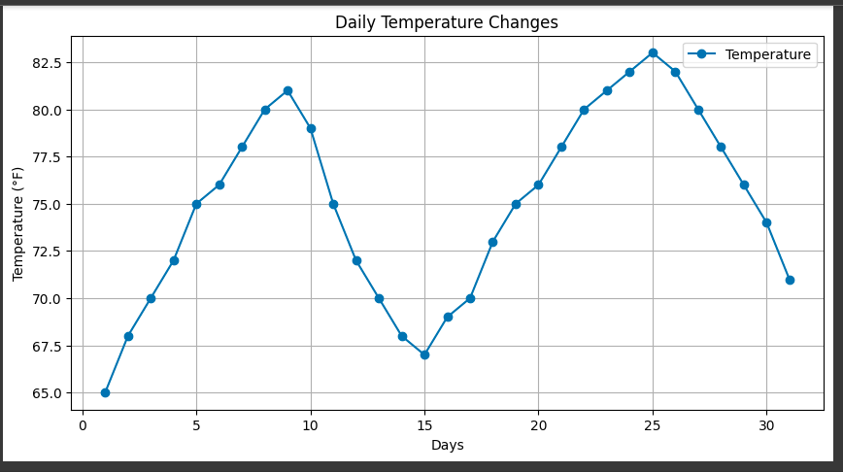

2: Create a line plot to visualize the daily closing prices of a stock over a year and give your conclusion.

Input: days = list(range(1, 78)) # Daily closing prices of a stock (replace with your own data)

stock_prices = [100, 105, 110, 115, 112, 120, 118, 125, 128, 130, 132, 135, 138, 140, 142, 144, 145, 148, 150, 155, 160, 158, 162, 165, 170, 172, 175, 178, 180, 182, 185, 188, 190, 192, 195, 198,200, 198, 195, 193, 190, 188, 185, 182, 180, 178, 175, 172, 170, 168, 165, 162, 160, 158, 155, 152, 150, 148, 145, 143, 140, 138, 135, 132, 130, 128, 125, 123, 120, 118, 115, 112, 110, 108, 105, 103, 100]

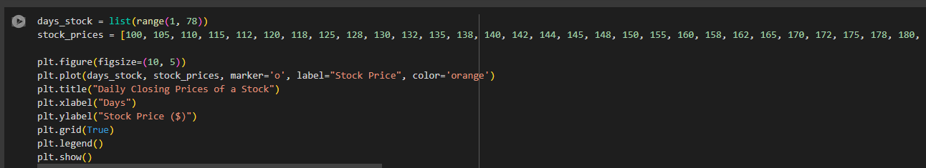

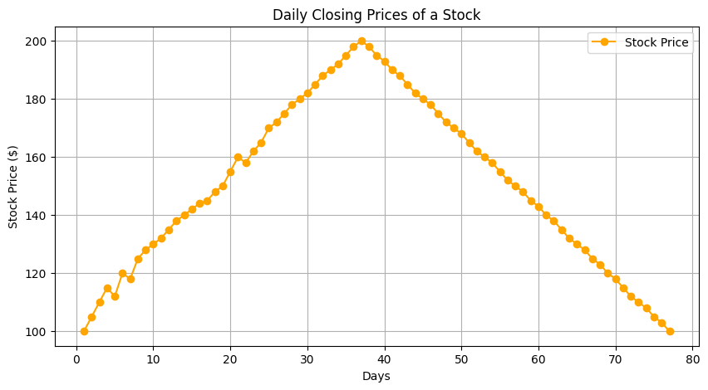

3: Create a bar chart to represent monthly expenses in different spending categories and give your conclusion.

Input: categories = ['Rent', 'Groceries', 'Utilities', 'Entertainment', 'Transportation']

# Monthly expenses in dollars (replace with your own data)

expenses = [1200, 400, 200, 150, 250]

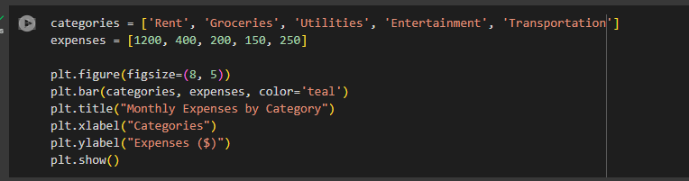

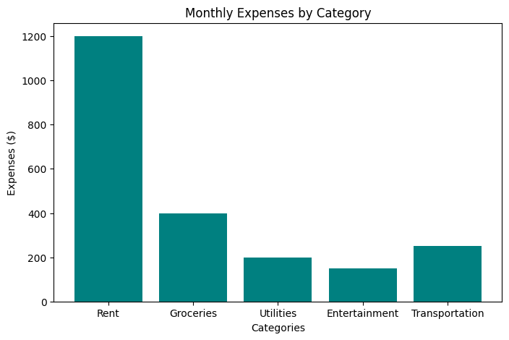

4: Create a histogram to represent the distribution of product prices in a retail store and give your conclusion.

Input: product_prices = [24.99, 34.99, 49.99, 64.99, 39.99, 54.99, 79.99, 99.99, 29.99, 44.99, 59.99, 69.99, 84.99, 109.99, 119.99, 89.99, 74.99, 124.99, 69.99, 54.99]

